

PCC DECISION | REF 2021/005

Decision Title: Treasury Management Strategy 2021/22

Decision summary:

- Approve the Treasury Borrowing Strategy (Section 2) for the financial year 2021-22.

- Approve the Treasury Investment Strategy (Section 3) for the financial year 2021-22.

- Note the Prudential Indicators (Section 4) for the financial years 2021-2024.

Background or reference to supporting papers:

Treasury Management Strategy 2021/22

Avon and Somerset Police & Crime Commissioner
I confirm I have considered whether or not I have any declarations of disclosable interest in this matter. Any such interests are disclosed.
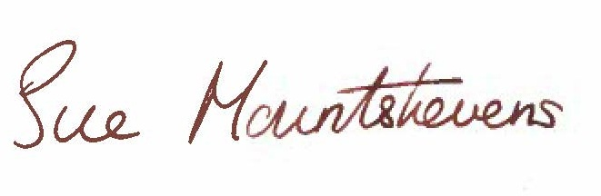
The above request has my approval.
Date 31.03.21

--------------------------------------------------------------------------
Police & Crime Commissioner for Avon & Somerset
CFO Signatures Date 07/04/21
(OCC CFO required if decision requested or presented for approval by Constabulary)
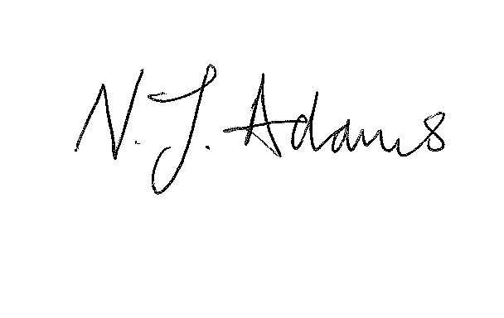
------------------------------- ------------------------------
PCC CFO OCC CFO
Other relevant lead officer as required Date 07/04/21
(e.g PCC CEO, COG lead)
Interim CEO Mark Simmonds 
---------------------------- ------------------------------------ ------------------------------
Job title name signature

