

PCC DECISION | REF 2021/012

Decision Title: Appointment of OPCC Chief of Staff (Chief Executive).

Decision summary:

The Appointment Panel and I unanimously agreed that Alice Ripley be appointed as Chief of Staff.

Therefore, I propose that the Police and Crime Panel endorse the appointment of Alice Ripley.

Background or reference to supporting papers:

Schedule 1, paragraph 6, of the Police Reform and Social Responsibility Act 2011 (PR&SRA) states that “the Police & Crime Commissioner (PCC) must appoint a person to be the head of the commissioner’s staff (referred to in this Part as the commissioner’s chief executive)”.

The appointment term will be full time and permanent.

An appointment process has been run and the campaign attracted a high-quality field of 25 applications. The applicants were assessed against an agreed appointment criteria and scored against a rating scale. Five candidates were shortlisted for the final selection stage.

The final selection process was run on a virtual basis due to continuing pandemic restrictions. The selection process comprised a presentation followed by a panel interview. Each element of the process related to a key element within the role profile.

The Appointment Panel unanimously agreed that Alice Ripley be appointed as Chief of Staff.

The appointment will be subject to a confirmation hearing with the Police & Crime Panel which will take place on 22 September 2021.

Avon and Somerset Police & Crime Commissioner
I confirm I have considered whether or not I have any declarations of disclosable interest in this matter. Any such interests are disclosed.

The above request has my approval.

Date 2/11/2021

--------------------------------------------------------------------------
Police & Crime Commissioner for Avon & Somerset
CFO Signatures Date 27/10/21
(OCC CFO required if decision requested or presented for approval by Constabulary)

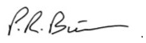
------------------------------- ------------------------------
PCC CFO OCC CFO
Other relevant lead officer as required Date 02/11/21
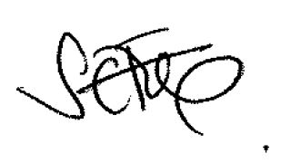
(e.g PCC CEO, COG lead)

Interim CEO Sally Fox
---------------------------- ------------------------------------ ------------------------------
Job title name signature

