

PCC DECISION | REF 2021/013

Decision Title: Appointment of Deputy Chief of Staff

Decision summary:

To run an internal recruitment process to appointment a Deputy Chief of Staff.

Background or reference to supporting papers:

The new Deputy Chief of Staff will support the new Chief of Staff settle into post, be responsible for the leadership and management of the OPCC team and provide support for the statutory monitoring officer duties to ensure effective corporate governance.

The appointment term proposed is a full time post for a 12 month fixed term contract. The appointment is proposed to provide continuity of advice to the new Chief of Staff and provide continuity of management of the OPCC team though this period.
Given the timing and context of the requirements of this short term post, the focus for candidates in this time limited role will be internal to OPCC. We do not consider there is time or value in seeking an external hire as this will take too long to be in post and would take too long to “get up to speed” with the role. The new Chief of Staff, the PCC and the OPCC team require stability and continuity of leadership.
Mark has spoken to the PCP Chair and the new Chief of Staff and they are supportive of the appointment.
We are not proposing that this appointment be subject to a confirmation hearing but we welcome the views of the Police & Crime Panel. Glos and Wilts OPCCs did not hold confirmation hearings for their Deputy CEO appointments
An appointment panel has been convened and 2 members of the Police & Crime Panel will be invited to observe the shortlisting and selection processes.

Appointments to OPCC in common with other public appointments are required to adhere to the Nolan Principles for Standards in Public Service which are: selflessness, integrity, objectivity, openness, accountability, honesty and leadership. The appointment must be made on merit, fairness and openness.

Avon and Somerset Police & Crime Commissioner
I confirm I have considered whether or not I have any declarations of disclosable interest in this matter. Any such interests are disclosed.


The above request has my approval.
Date

--------------------------------------------------------------------------
Police & Crime Commissioner for Avon & Somerset
CFO Signatures Date 15th Nov 21
(OCC CFO required if decision requested or presented for approval by Constabulary)
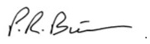
------------------------------- ------------------------------
PCC CFO OCC CFO
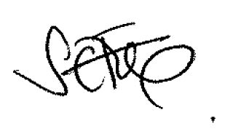
Other relevant lead officer as required Date 15th Nov 21
(e.g PCC CEO, COG lead)

Interim CEO Sally Fox
---------------------------- ------------------------------------ ------------------------------
Job title name signature

