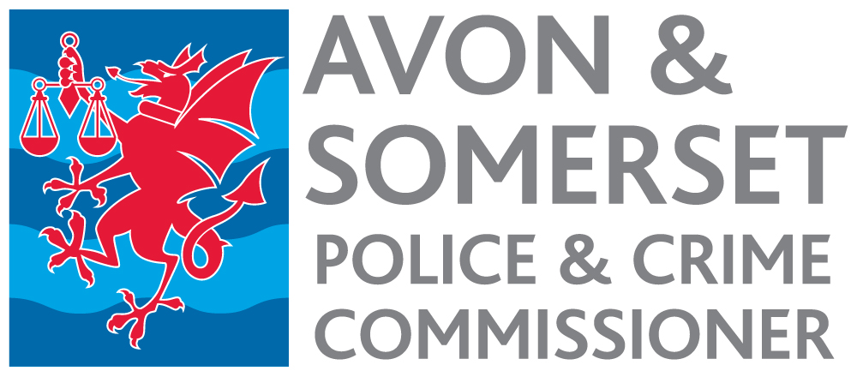

Communications Officer – Violence Reduction Unit Appointment process 2022

Timetable

Date | Activity
Week commencing  13 June | Advertisement published.
12 noon 14 July | Closing date for receipt of applications.
19 July | Short listing.
20 July | Notification to short-listed candidates.
4 or 5 Aug | Selection Day.
8 Aug | Notification to successful candidate.
Early Oct | Start date.

