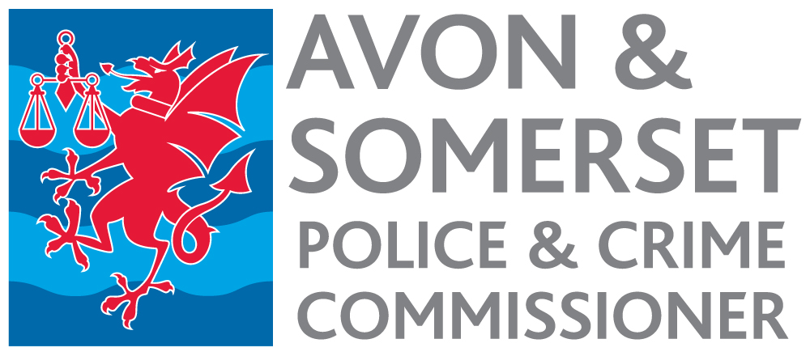

Evaluation and Impact Senior Lead – Violence Reduction Unit Appointment process 2022

Timetable

Date | Activity
Week commencing  6 June 2022 | Advertisement published.
12 noon 30 June | Closing date for receipt of applications.
8 July | Short listing.
11 July | Notification to short-listed candidates.
20 or 21 July | Selection Day.
21 July | Notification to successful candidate.
Early October | Start date.

