

PCC DECISION | REF 2022/001

Decision Title: Avon and Somerset Sexual Assault Referral Centre (SARC) Procurement Outcome

Decision summary:

The Police and Crime Board is asked to:
- approve commencement to award as per the NHS England and Improvement recommendation paper; and
- direct relevant authorities in the OPCC and ASC to sign page 4 of the attached Avon and Somerset Executive Summary Document.

Background or reference to supporting papers:

NHSEI Health and Justice South West is the lead commissioner for the Avon and Somerset SARC, with the OPCC and Constabulary co-commissioners funding part of the core service and forensic medical examiners respectively. This new contract brings together these two previously separate elements into an integrated service for the first time and transfers the contract management responsibility for the forensic medical element (currently managed by South West Police Procurement) to health. The attached executive summary lists the benefits of this new model.

Funding
The contribution to the service p.a. is:

Authority | Annual | Total
NHSE/I | £1,053,000  (+£90k for mobilisation) | £7,459,000
OPCC | £247,000 | £1,732,000
Police | £448,000 | £3,135,000

Year 1 Annual Contract Value | Years 2-7 Annual Contract Value | Total Contract Value
£1,838,000 | £1,748,000 | £12,326,000

The OPCC contribution is inclusive of an agreed £19k uplift to this budget from April 2022 in order to match fund a £321k increase from NHSE to reflect the significant increases in demand for SARC services during the commissioning process.

A MOU has been drafted to cover the payment of funds from ASC and the OPCC to NHSEI as lead commissioner.

Process
The OPCC was represented and actively participated during the procurement process as set out in the attached paper by the Senior Commissioning and Policy Officer responsible for Victim Services and the Constabulary by the T/DCI for Bluestone. Both have the relevant expertise in the Rape and Serious Sexual Offences (RASSO) pathway and will attend regular contract review meetings with the SARC service.

Avon and Somerset Police & Crime Commissioner
I confirm I have considered whether or not I have any declarations of disclosable interest in this matter. Any such interests are disclosed.

The above request has my approval.
Date 24/05/22

--------------------------------------------------------------------------
Police & Crime Commissioner for Avon & Somerset
CFO Signatures Date 03/03/22
(OCC CFO required if decision requested or presented for approval by Constabulary)
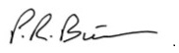

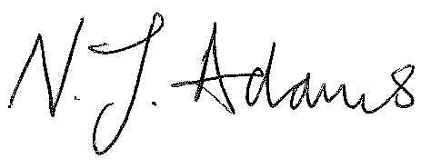
------------------------------- ------------------------------
PCC CFO OCC CFO
Other relevant lead officer as required Date 24/05/22

(e.g PCC CEO, COG lead)

Chief of Staff Alice Ripley
---------------------------- ------------------------------------ ------------------------------
Job title name signature

Attached – Avon and Somerset Executive Summary (for signature)

Attached - Contract Award Recommendation Report – STRICTLY CONFIDENTIAL COMMERICALLY SENSITIVE. For decision makers only.

