

PCC DECISION | REF 2022/002

Decision Title: Treasury Management Strategy 2022/23

Decision summary:

- Approve the Treasury Borrowing Strategy (Section 2) for the financial year 2022-23.

- Approve the Treasury Investment Strategy (Section 3) for the financial year 2022-23.

- Note the Prudential Indicators (Section 4) for the financial years 2022-2025.

Background or reference to supporting papers:

Treasury Management Strategy 2022/23.

Avon and Somerset Police & Crime Commissioner
I confirm I have considered whether or not I have any declarations of disclosable interest in this matter. Any such interests are disclosed.

The above request has my approval.
Date 24/05/22

--------------------------------------------------------------------------
Police & Crime Commissioner for Avon & Somerset
CFO Signatures Date 03/03/22

(OCC CFO required if decision requested or presented for approval by Constabulary)

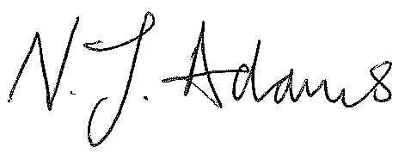
------------------------------- ------------------------------
PCC CFO OCC CFO
Other relevant lead officer as required Date 24/05/22

(e.g PCC CEO, COG lead)

Chief of Staff Alice Ripley
---------------------------- ------------------------------------ ------------------------------
Job title name signature

