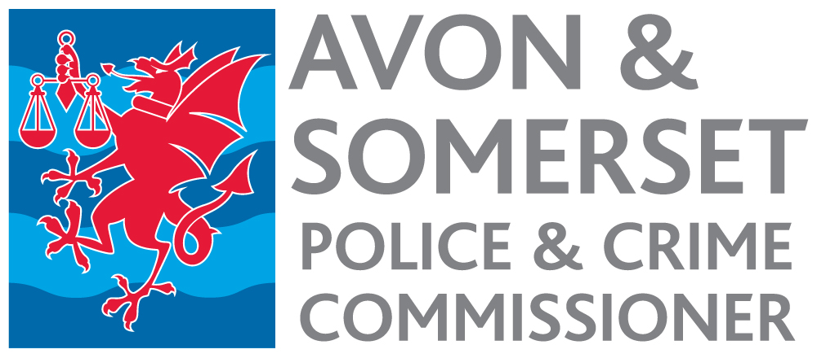

Senior Scrutiny and Assurance Manager
Appointment process 2022

Timetable

Date | Activity
Week commencing  8 August 2022 | Advertisement published.
12 noon 5 September | Closing date for receipt of applications.
w/c 12 September | Short listing.
16 September | Notification to short-listed candidates.
w/c 19 September | Selection Day.
23 September | Notification to successful candidate.
October - December | Start date, depending on notice period.

