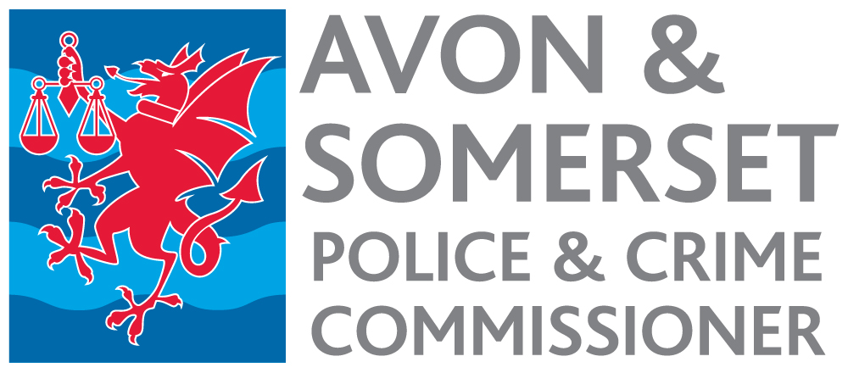

Communications Manager – Violence Reduction Unit Appointment process 2022

Timetable

Date | Activity
28 July | Advertisement published.
12 noon 25 August | Closing date for receipt of applications.
Week commencing  5 September | Short listing.
9 September | Notification to short-listed candidates.
w/c 12 or 19 September | Selection Day.
23 September latest | Notification to successful candidate.
November/December | Start date.

