

PCC DECISION | REF 2022/003

Decision Title: Avon and Somerset Sexual Violence Therapies Service – contract award

Decision summary:

Approval to award contract for Avon and Somerset Sexual Violence Therapies Service [retrospective]

Background or reference to supporting papers:

The total value of the Avon & Somerset Sexual Assault & Abuse Therapies Service is £657,433.00 per annum, with a total contract lifecycle value of £3,944.598.00 over 6 years. The 6-year period will commence from 1st April 2023.
The OPCC contribution is £132.248 p.a. and is funded by the MOJ formula-based victim services grant. A Memorandum of Understanding will be prepared to allow for the transfer of OPCC funding to the Lead Commissioner (NHSE).
The Services procured through this tender process are healthcare services falling within Schedule 3 to the Public Contracts Regulations 2015 (‘the Regulations’) and represent an integration of a number of services which are currently commissioned and funded by: Avon and Somerset Office of the Police and Crime Commissioner, BNSSG ICB, Bristol City Council and NHS England. The current Services are due to expire on 31st March 2023. The OPCC was represented throughout the commissioning exercise and approves this recommendation.
The recommendation following the procurement is to approve NHSE to award the service to SARSAS (Somerset and Avon Rape and Sexual Abuse Support).
Reference Paper: Contract Award Recommendation Report for the provision of an Avon & Somerset Sexual Assault and Abuse Therapies Services to NHS England (South West)

Avon and Somerset Police & Crime Commissioner
I confirm I have considered whether or not I have any declarations of disclosable interest in this matter. Any such interests are disclosed.


The above request has my approval.
Date 07/12/22

--------------------------------------------------------------------------
Police & Crime Commissioner for Avon & Somerset
CFO Signature Date 07/12/22
(OCC CFO required if decision requested or presented for approval by Constabulary)
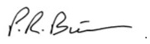

-------------------------------
PCC CFO
Other relevant lead officer as required Date 07/12/22
(e.g PCC CEO, COG lead)
Chief of Staff Alice Ripley 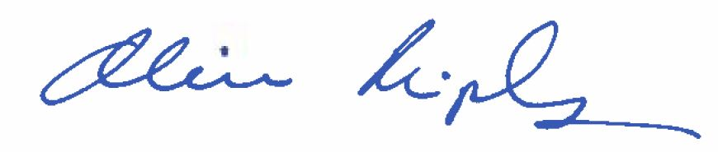
---------------------------- ------------------------------------ ------------------------------
Job title name signature

