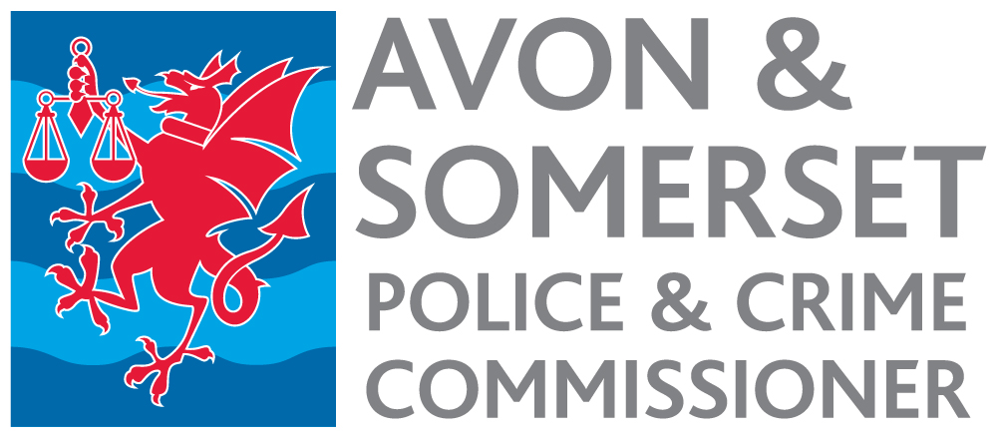

Scrutiny and Assurance Manager
Appointment process 2022

Timetable

Date | Activity
13 January 2023 | Advertisement published.
12 noon 3 February | Closing date for receipt of applications.
w/c 6 February | Short listing.
10 February | Notification to short-listed candidates.
w/c 27 February | Selection Day.
3 March | Notification to successful candidate.
April/May | Start date, depending on notice period.

