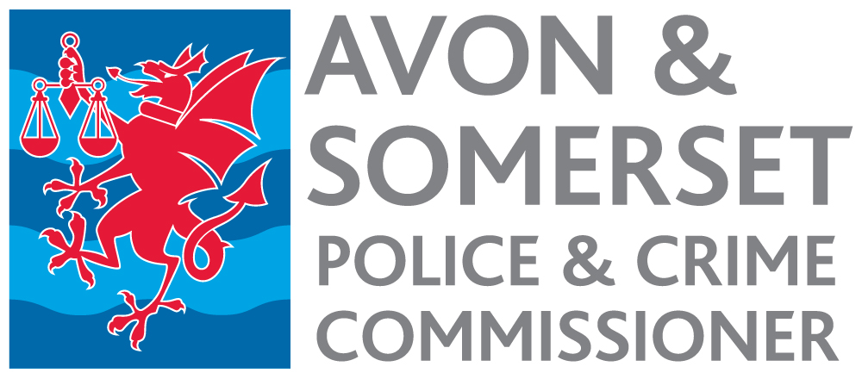

Joint Audit Committee
Role Profile
Chair

- KEY RESPONSIBILITIES

The Joint Audit Committee (JAC) is an important, independent means of enhancing public trust and confidence in the governance of the Office of the PCC (“OPCC”) and Avon & Somerset Police. It also assists the Police & Crime Commissioner (PCC) in discharging statutory responsibilities in holding the Police Force to account. This is achieved by;

- Advising the OPCC and Chief Constable according to good governance principles;
- Providing independent assurance on the adequacy and effectiveness of the OPCC and Avon & Somerset Police internal control environment and risk management framework;
- Overseeing the effectiveness of the framework in place for ensuring compliance with statutory requirements;
- Independently scrutinising financial and non-financial areas (e.g. HR, Operations, IT systems) to the extent that it affects the OPCC and Avon & Somerset Police exposure to risks and weakens the internal control environment;
- Overseeing the financial reporting process;
- Overseeing audit functions.

  - The Chair of the JAC is responsible for providing leadership to the JAC for the purpose of it effectively setting and discharging the JAC Terms of Reference.

  - Ensuring that the JAC remains suitably independent in achieving its purpose as set out in its Terms of Reference and that this is done so in a professional and diligent manner.

  - The Chair, within the context of making the JAC effective, must create and manage effective working relationships between:

- JAC members;
- the Police and Crime Commissioner (PCC);
- the Chief Constable;
- the Chief Finance Officer’s (CFO’s) of both the PCC and Chief Constable;
- other nominated or appropriate representatives from either the PCC and Chief Constable;
- Internal Audit; and
- External Audit.

  - Meet separately with the Chief Finance Officer of both the PCC and Chief Constable to discuss risk and control related issues that the JAC will need to consider for the purposes of fulfilling their Terms of Reference and seek advice from each of the CFO’s with regards to how these risk issues might be resolved.

  - Meet separately, as required, with the internal auditor and / or external auditor to discuss issues raised that stem from their audit activity, or to discuss issues that the JAC Chair wishes to raise with them.

  - Act as the JAC’s spokesperson.

- Conduct of JAC meetings

  - Act as the Chair of each JAC meeting ensuring the appropriate conduct of business in accordance with the Terms of Reference.

  - Ensure that the members of the JAC understand and have accepted the code of conduct in place and relevant to each member.

  - Conduct the business of each JAC meeting in a manner which will result in all matters on the agenda being dealt with effectively and appropriately.

  - Propose the termination of discussion on any matter when in the view of the Chair that the matter has been thoroughly canvassed and discussed and that no new points of view or information are being presented.

  - Attempt to achieve resolution of all issues discussed at the meeting in respect of which a decision is required and members express conflicting positions, views, or advice, but such attempt should in no way inhibit a member from maintaining a different position, view, or advice.

  - Ensure that all members who wish to address a matter at a meeting are afforded a reasonable opportunity to do so.

  - Require members to identify any conflicts of interest at the commencement of the JAC meeting. In any case where a member of the JAC has an interest or potential conflict in respect of a matter that may arise through discussion at a meeting, arrange for that member to excuse himself/herself from all or a portion of the discussion.

3 JAC Culture

3.1 Provide leadership in promoting and supporting a culture within the JAC characterised by the following:

- The willingness of each member to use their best efforts in carrying out their duties as a member of the JAC;

- The JAC’s insistence on the highest level of integrity, accountability and honesty in its actions and of the PCC, Chief Constable and the other officers of the Office of the PCC (“OPCC”) and Force as set out in the respective codes of conduct;

- Respect and dignity among the members and all those that attend the JAC meetings;

- The appropriate and timely sharing of information among the members of the JAC and all those expected to attend the meeting;

- Acceptance by all JAC members of the right to hold and express an opinion, within the context of the JAC business as determined by the Terms of Reference and individual meeting agendas, minutes and papers;

- A commitment amongst JAC members to best governance practices and standards.

4 Miscellaneous Matters

4.1 Whenever necessary or desirable, to facilitate the effective performance of the JAC, attend or arrange member attendance at other relevant meetings and committees of the PCC and Chief Constable.

